Parents and
Carers Survey Results

2020-2021

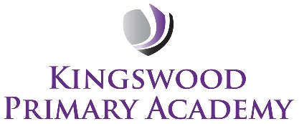

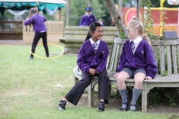

Parent survey results – 2020-2021
Introduction
Each year we seek the views of the parents and carers at Kingswood Primary Academy about various aspects of our work.
The outcomes below are the parents and carers perceptions of the different questions asked. This helps us to better understand the work of our academy, what we do well and the areas we need to improve from the perspective of the parents.
This information is used in conjunction with the Pupil Attitude Survey and internal monitoring and evaluation that the leadership of the academy undertakes.
We will ensure that the outcomes with required improvement are used to shape updates to the academy development plan so that we can do things better from the parents and carers perspective.

Overall outcomes

No. | Questions | Oct 20
1 | My child feels safe at this school. | 98%
2 | My child is making good progress at this school. | 100%
3 | My child enjoys the creative curriculum and is motivated by it. | 100%
4 | This school meets my child’s particular needs. | 98%
5 | This school ensures my child is well looked after. | 98%
6 | My child is taught well at this school. | 100%
7 | This school helps my child to develop skills in communication, reading, writing and mathematics. | 100%
8 | There is a good standard of behaviour at this school. | 95%
9 | This school deals with any cases of bullying effectively. (Bullying includes persistent name-calling, cyber, racist and homophobic bullying). | 98%
10 | This school responds well to my concerns and is approachable. | 97%
11 | This school keeps me well informed and communicates with me effectively (e.g. newsletters, text service, curriculum newsletters, website) | 98%
12 | I know how well my child is doing at school (Through parent evenings, end of year reports, informal talks with teachers) | 100%
13 | This school communicates how important it is for the children to have good attendance. I am well informed about my child’s attendance. | 100%
14 | I would recommend this school to another parent. | 97%

(65 responses)

What are we doing to improve?

- Support for pupils with specific needs
- NSPCC Safer Internet workshops for parents, carers and pupils
- Celebrating diversity
- Parental engagement activities
- Updated website
- Increased use of Twitter, Facebook and Teams
- Texts to parents
- Recruitment of experienced staff

Further improvements planned:

- Curriculum development
- Teacher development activities

As always, we appreciate your views and welcome visits to the academy at any time if you have a concern or worry that you wish to share.

Our academy ethos

