Home Learning - wb 07.06.2022 Week 1
English  Narrative Writing | Monday | Lesson 1
 | Tuesday | Lesson 2
 | Wednesday | Lesson 3
 | Thursday | Lesson 4
 | Friday | Lesson 5
Maths  Geometry – Position and Direction | Monday
 | Tuesday | Click on this link to watch a video.  Click on this link to complete the activity.
 | Wednesday | Click on this link to watch a video.  Click on this link to complete the activity.
 | Thursday | Click on this link to watch a video.  Click on this link to complete the activity.
 | Friday | Click on this link to watch a video.  Click on this link to complete the activity.
Reading  The Giant's Necklace by Michael Morpurgo | Monday | Lesson 1
 | Tuesday | Lesson 2
 | Wednesday | Lesson 3
 | Thursday | Lesson 4
 | Friday | Lesson 5
Topic | The Maya - History  When and where did the Maya live?  Place the Maya on a timeline of the history they have studied including Ancient Egyptians, Iron Age, Bronze Age, Roman invasion, Anglo-Saxons, Victorians and WW2. Create a timeline to show how the Maya tie in with other civilisations learned about in KS2.  French Lesson 1 and 2  P.E Lesson 1  Computing Lesson 1  PSHE Lesson 1  Art Lesson 1
Science  Our Changing World | Identify how animals and plants are adapted to suit their environment in different ways and that adaptation may lead to evolution.  Produce a double page spread about a plant or an animal that you have researched.
Useful links (Click on the word)
- Times Tables Rockstars
- Spelling Shed
- Purple Mash
- Bitesize Home Learning

Home Learning - wb 13.06.22 Week 2
English  Narrative Writing | Monday | Lesson 6
 | Tuesday | Lesson 7
 | Wednesday | Lesson 8
 | Thursday | Lesson 9
 | Friday | Lesson 10
Maths  Calculation Problems | Monday | Lesson 1
 | Tuesday | Lesson 2
 | Wednesday | Lesson 3
 | Thursday | Lesson 4
 | Friday | Lesson 5
Reading  The Blitz Survivor Stories | Monday | Lesson 1
 | Tuesday | Lesson 2
 | Wednesday | Lesson 3
 | Thursday | Lesson 4
 | Friday | Lesson 5
Topic | The Maya - History  What artefacts tell us about the Maya?  Look at a photo of a statuette of Lady K’Bel - (this figurine, thought to depict Lady K'abel, was excavated from a burial site in 2006.) What questions would you like to ask this character?  K’abel, was considered the greatest ruler of the Late Classic period, she ruled with her husband, K’inich Bahlam, for at least 20 years (672-692 AD). She was the military governor of the Wak kingdom for her family, and she carried the title “Kaloomte’,” translated to “Supreme Warrior,” higher in authority than her husband, the king.  What does this tell us about Maya society and who could rule?  French Lesson 3 and 4  P.E Lesson 2  Computing Lesson 2  PSHE Lesson 2  Art Lesson 2
Science  Our Changing World | Describe the differences in the life cycles of a mammal, an amphibian, an insect and a bird; identify how animals and plants are adapted to suit their environment in different ways and that adaptation may lead to evolution.
Useful links (Click on the word)
- Times Tables Rockstars
- Spelling Shed
- Purple Mash
- Bitesize Home Learning

Home Learning- wb 20.06.22 Week 3
English  Narrative Writing | Monday | Lesson 11
 | Tuesday | Lesson 12
 | Wednesday | Lesson 13
 | Thursday | Lesson 14
 | Friday | Lesson 15
Maths  Calculation Problems | Monday | Lesson 6
 | Tuesday | Lesson 7
 | Wednesday | Lesson 8
 | Thursday | Lesson 9
 | Friday | Lesson 10
Reading  The Greenling by Levi Pinfold | Monday | Lesson 1
 | Tuesday | Lesson 2
 | Wednesday | Lesson 3
 | Thursday | Lesson 4
 | Friday | Lesson 5
Topic | The Maya - HIstory  What was Maya writing like and what can it tell us about their society?  The Maya had emblem glyphs for their cities, much as sport teams have insignia.  Stelae were carved standing stones that represented the major events in a ruler’s life such as accession to the throne, marriage, conquest and so on. Using the information from the booklet students can draw their own stelae and record important events in their lives.  For the Maya, writing and painting were virtually identical and within the glyphs themselves there is a strong link between text and picture. Try and decipher Maya glyphs with the knowledge that for the Maya pictures and text were closely linked. Decode the glyphs on a Maya Stelae or pyramid. Compare the glyphs to Egyptian writing. The Maya were one of only a few civilisations to develop writing at that time. Others include the Egyptians, Sumerians and Shang dynasty.  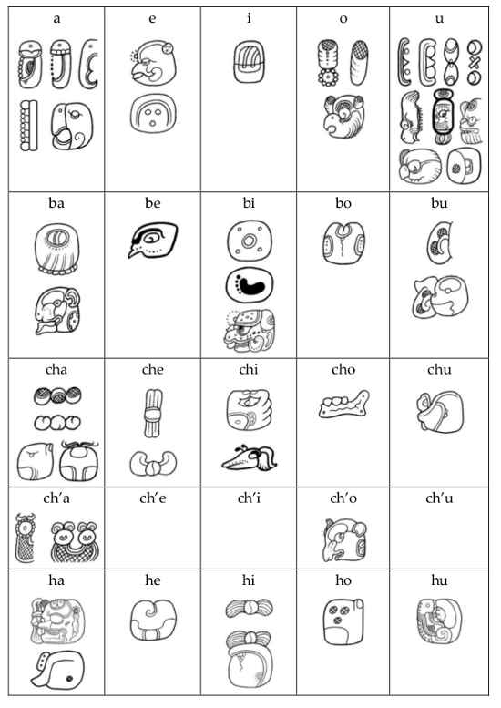  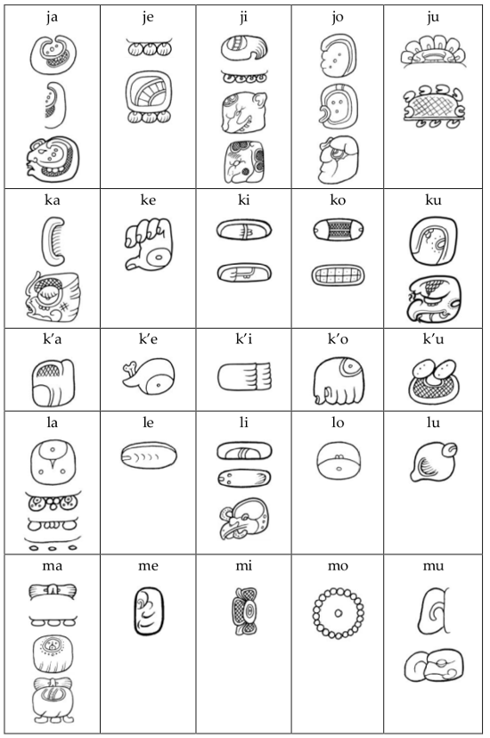  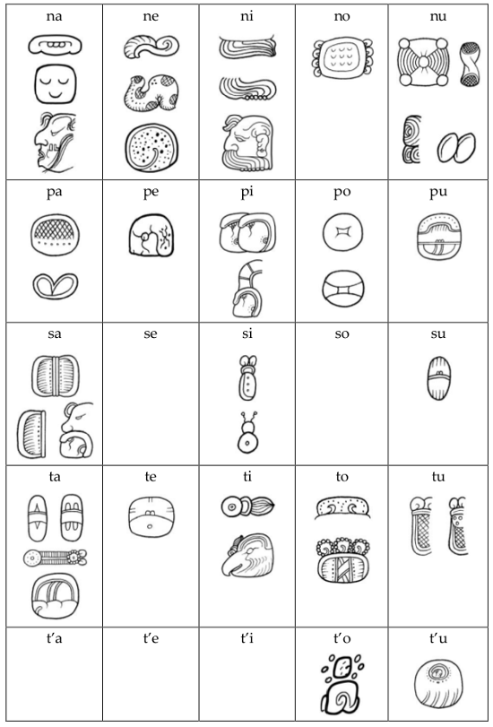  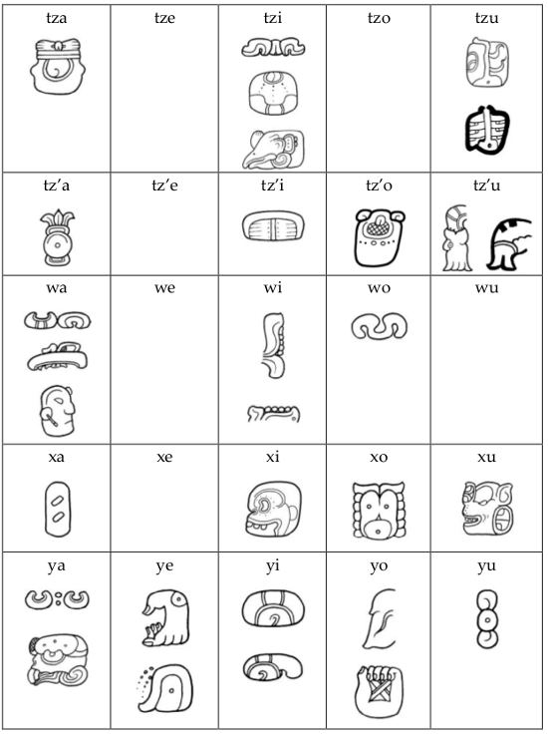  Make your own emblem glyph thinking about the attributes of Corby.  French Lesson 5  P.E Lesson 3  Computing Lesson 3  PSHE Lesson 3  Art Lesson 3
Science  Our Changing World | Describe the differences in the life cycles of a mammal, an amphibian, an insect and a bird; recognise that living things produce offspring of the same kind, but normally offspring vary and are not identical to their parents
Useful links (Click on the word)
- Times Tables Rockstars
- Spelling Shed
- Purple Mash
- Bitesize Home Learning

Home Learning- wb 27.06.22 Week 4
English  Narrative Writing | Monday | Lesson 16
 | Tuesday | Lesson 17
 | Wednesday | Lesson 18
 | Thursday | Lesson 19
 | Friday | Lesson 20
Maths  Calculation Problems | Monday | Lesson 6
 | Tuesday | Lesson 7
 | Wednesday | Lesson 8
 | Thursday | Lesson 9
 | Friday | Lesson 10
Reading  Holes by Louis Sachar | Monday | Lesson 1
 | Tuesday | Lesson 2
 | Wednesday | Lesson 3
 | Thursday | Lesson 4
 | Friday | Lesson 5
Topic | The Maya - History  How did the Maya tell the time?  Discuss the 52-year calendar round (made up of the sacred year and solar year) and the Long Count system (see information in folder)  Children could calculate their birthdates in the Maya calendar: On the FAMSI website there is an interactive date conversion where can type in for example today’s date and it will give you the date in the Maya calendar. http://research.famsi.org/date_mayaLC.php  Children could make a calendar.  French Lesson 1 and 2  P.E Lesson 4  Computing Lesson 4  PSHE Lesson 4  Art Lesson 4
Science  Our Changing World | Research two different bird types. Find out how their behaviours change over he year.
Useful links (Click on the word)
- Times Tables Rockstars
- Spelling Shed
- Purple Mash
- Bitesize Home Learning

Home Learning- wb 04.07.22 Week 5
English  Narrative Writing | Monday | Lesson 21
 | Tuesday | Lesson 22
 | Wednesday | Lesson 23
 | Thursday | Lesson 24
 | Friday | Lesson 25
Maths  Large Numbers | Monday | Lesson 6
 | Tuesday | Lesson 7
 | Wednesday | Lesson 8
 | Thursday | Lesson 9
 | Friday | Lesson 10
Reading  The Giant's Necklace by Michael Morpurgo | Monday | Lesson 1
 | Tuesday | Lesson 2
 | Wednesday | Lesson 3
 | Thursday | Lesson 4
 | Friday | Lesson 5
Topic | The Maya - History  Did the Maya play football like us?  Children learn about the ancient Maya ball game and its cultural significance and compare it with other spectator sports past and present. Show a picture of a ball court at Uxmal. Explain how the ball game was played. https://www.mexicolore.co.uk/aztecs/aztefacts/oh-balls https://www.bbc.co.uk/bitesize/topics/zq6svcw/articles/zbqyy4j?scrlybrkr=b8175f14  Do you think the England team would like to play the Maya ball game? Why?  Identify the similarities and differences between modern football and the Maya ball game.  French Lesson 3 and 4  P.E Lesson 5  Computing Lesson 5  PSHE Lesson 5  Art Lesson 5
Science  Our Changing World | Find out what happens to invertebrates during the year.  Describe how living things are classified into broad groups according to common observable characteristics, similarities and differences, including micro-organisms, plants and animals; identify how animals and plants are adapted to suit their environment in different ways and that adaptation may lead to evolution.
Useful links (Click on the word)
- Times Tables Rockstars
- Spelling Shed
- Purple Mash
- Bitesize Home Learning

Home Learning- wb 11.07.22 Week 6
English  Narrative Writing (Monday and Tuesday) | Monday | Lesson 26
 | Tuesday | Lesson 27
 | Wednesday | Simple and Compound Sentences
 | Thursday | To explore complex sentences
 | Friday | Relative Clauses
Maths  Large Numbers | Monday | Lesson 11
 | Tuesday | Lesson 12
 | Wednesday | Lesson 13
 | Thursday | Lesson 14
 | Friday | Lesson 15
Reading  The Blitz Survivor Stories | Monday | Lesson 1
 | Tuesday | Lesson 2
 | Wednesday | Lesson 3
 | Thursday | Lesson 4
 | Friday | Lesson 5
Topic | The Maya  How significant was Gonzalo Guerrero?  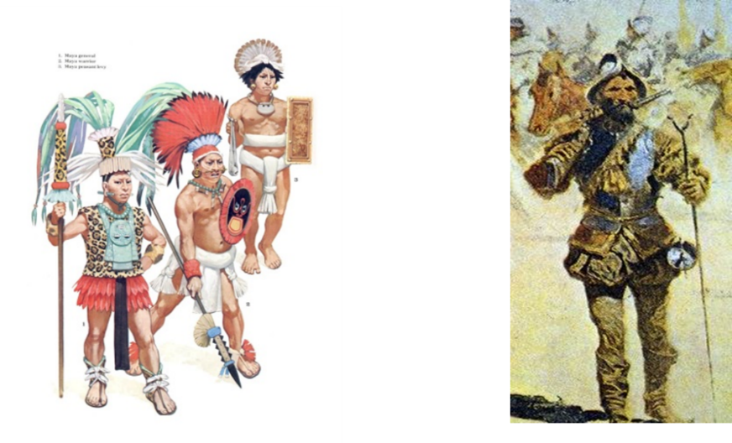  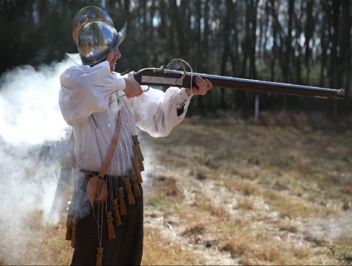  Explain what an aquebus is. See photo.  Ask – In the event of a battle between these two, which one was likely to win? Why?  Explain that the Maya were most powerful up to around AD 900, when they begin to decline. They don’t disappear altogether – after all  there are around 7 million Maya alive in the area today. The fact that they, as a Stone-Age people, were able to resist the Spanish for so long tells us they were important. But just how important was the role of Gonzalo Guerrero in all this? Does he deserve to be?  Explain that people are significant if they  - changed events at the time they lived.  - improved lots of people’s lives – or made them worse.  - changed people’s ideas.  - had a long-lasting impact on their country or the world.  - had been a really good or a very bad example to other people of how to live or behave.  French Lesson 1 and 2  P.E Lesson 6  Computing Lesson 6  PSHE Lesson 6  Art Use the knowledge you have gained about graphic design to draw the heart is 3D form.
Useful links (Click on the word)
- Times Tables Rockstars
- Spelling Shed
- Purple Mash
- Bitesize Home Learning

