RE
At
Kingswood Primary Academy
Kingswood Primary Academy Curriculum Intent
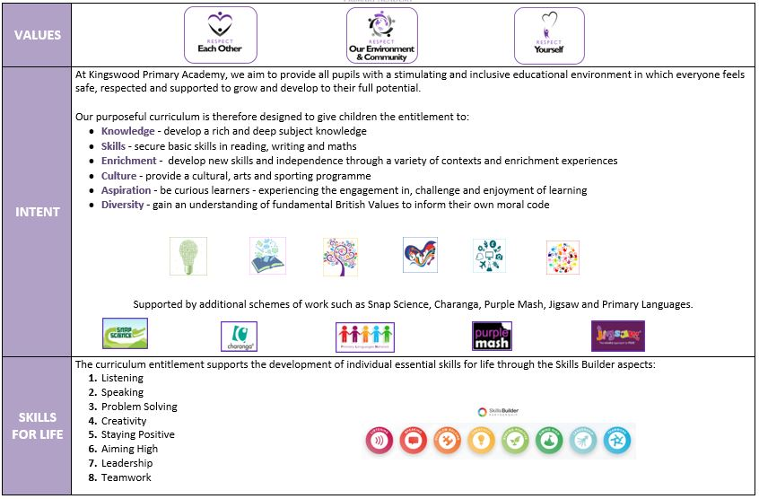
Overview
At Kingswood Primary Academy we use the Discovery RE as a basis for our RE teaching.

Discovery RE is a comprehensive set of detailed medium-term planning for Religious Education from Nursery to Year 6. Enquiry modules covering Christianity, Buddhism, Hinduism, Islam, Judaism and Sikhism support the teacher to deliver engaging and challenging RE lessons with confidence.

Christianity is taught in every year group, with Christmas and Easter given fresh treatment each year, developing children’s learning in a progressive way.

Intent
At Kingswood Primary Academy, we believe that it is important for all our pupils to learn from and about religion, so that they can understand the world around them. The aim of Religious Education in our school is to help children to acquire and develop knowledge and understanding of Christianity and the other principal religions represented in Great Britain; to appreciate the way that religious beliefs shape life and behaviour, develop the ability to make reasoned and informed judgements about religious and moral issues and enhance their spiritual, moral, social and cultural development. This ties in directly with our school values: respect each other, respect yourself, respect our environment and community.

Religious Education is taught throughout the school in such a way as to reflect the overall aims, values, and philosophy of the school.

We encourage our pupils to ask questions about the world and to reflect on their own beliefs, values and experiences. Our curriculum is designed to encourage creativity, imagination, enquiry, debate, discussion and self-reflection.

Implementation
We use the Discovery RE scheme as the basis for our Curriculum which follows an inquiry-based approach as well as SMSC developmental opportunities. At Kingswood, the following religions have been selected for study: Christianity, Islam, Judaism, Hinduism, Buddhism and Sikhism There are no presumptions made as to the religious backgrounds and beliefs and values of the children and the staff. We value the diverse religious background of all members of the school community and hope that this will encourage individuals to share their own experiences with others freely. All religions and their communities are treated with respect and sensitivity, and we value the links, which are, and can be made between home, school, and a faith community. We promote teaching in Religious Education that stresses open enquiry and first-hand experiences wherever possible for both staff and children. Children are encouraged to ask questions as part of their learning through the use of learning owls. This gives the teacher a greater insight into children’s thinking as well as providing ongoing assessment opportunities.

Impact
We measure the impact of our curriculum through the following methods:
-Assessing children’s understanding of topic linked vocabulary before and after the unit is taught.
-Pupil discussions about their learning.
The use of knowledge organisers to support pupils to know and remember more.
-Interviewing the pupils about their learning (pupil voice).
-Marking of written work in books.
-Through their R.E. learning, the children are able to make links between their own lives and those of others in their community and in the wider world, developing an understanding of other people’s cultures and ways of life. As such, R.E. is invaluable in an ever changing and shrinking world.

Curriculum Design
The aims of the syllabus are for pupils:
• to develop religious literacy.
• to acquire and develop knowledge and understanding of Christianity and the other principal religions and world views represented in the United Kingdom.
• to develop an understanding of the influence of the beliefs, values and traditions on individuals, communities, societies and cultures.
• to develop attitudes of respect towards other people who hold views and beliefs different from their own.
• to develop the ability to make reasoned and informed judgements about religious issues, with reference to the principal religions and world views
represented locally and in the United Kingdom.

Religions deal with some of the most profound and difficult questions in human life, questions such as:
• What is the purpose of life?
• How should people treat each other?
• How do we explain and cope with death and suffering? Religions approach these issues in complex ways, in ways of life, culture and action, as well as ritual,
tradition, story, symbol and belief.

Religious Education must take account of this depth and complexity, helping pupils to an understanding appropriate to their age and aptitude.
Year | Key Learning Sequence |  | Religious Focus and Connections
EYFS | Communication and Language  - Who is in my family?  - How do they help me?  - Talk about celebrations of Halloween/ fireworks/ Diwali/ Birthdays/Christmas  - Perform the Nativity  - Helicopter stories  - Language of cooperation when building together during large scale modelling  PSED  - Making relationships  - Establishing rules and boundaries  - Celebrating special times  - How do you feel when you celebrate?  - Keeping healthy  - Cooperation  - Caring for others and the environment  - Managing our feelings  UTW  - How do I feel when celebrating?  - Similarities/differences Celebrating special times |  | - Develop their sense of responsibility and membership of a community.  - Continue to develop positive attitudes about the differences between people.  - See themselves as a valuable individual.  - Think about the perspectives of others.  - about members of their immediate family and community.  - Name and describe people who are familiar to them.  - Understand that some places are special to members of their community.  - Recognise that people have different beliefs and celebrate special times in different ways.
Y1 | - Christianity  - Judaism |  | - Does God want Christians to look after the world?  - What gift would I have given to Jesus if He had been born in my town and not in Bethlehem?  - Was it always easy for Jesus to show friendship?  - Why was Jesus welcomed  - like a king or celebrity by the crowds on Palm Sunday?  - Is Shabbat important to Jewish children?  - Does celebrating Chanukah make Jewish children feel closer to God?
Y2 | - Christianity  - Judaism |  | - Is it possible to be kind to everyone all of the time?  - Why do Christians believe God gave Jesus to the world?  - How important is it to Christians that Jesus came back to life after his crucifixion?  - How important is it for Jewish people to do what God asks them to do?  - How special is the relationship Jews have with God?  - What is the best way for a Jew to show commitment to God?
Y3 | - Hinduism  - Christianity |  | - Has Christmas lost its meaning?  - Could Jesus heal people? Were these miracles or is there some other explanation?  - What is ‘good’ about good Friday?  - Would celebrating Diwali at home and in the community bring a feeling of belonging to a Hindu child?  - How can Brahman be everywhere and in everything?  - Would visiting the River Ganges feel special to a non-Hindu?
Y4 | - Buddhism  - Christianity |  | - What is the most significant part of the nativity story for Christians today?  - Is forgiveness always possible for Christians?  - Do people need to go to church to show they are Christians?  - Is it possible for everyone to be happy?  - Can the Buddha’s teachings make the world a better place?  - What is the best way for a Buddhist to lead a good life?
Y5 | - Sikhism  - Christianity |  | - Is the Christmas Story true?  - How significant is it for Christians to believe God intended Jesus to die?  - What is the best way for a Christian to show commitment to God?  - How far would a Sikh go for his/her religion?  - Are Sikh stories important today?  - What is the best way for a Sikh to show commitment to God?
Y6 | - Islam  - Christianity |  | - Do Christmas celebrations and traditions help Christians understand who Jesus was and why he was born?  - Is anything ever eternal?  - Is Christianity still a strong religion 2000 years after Jesus was on Earth?  - What is the best way for a Muslim to show commitment to God?  - Does belief in Akhirah (life after death) help Muslims lead good lives?  - Does belief in Akhirah (life after death) help Muslims lead good lives?
SEND – Strategies for supporting access  - Break down learning – now/then  - Adult support – start off then independent (where possible)  - Images to support  - Specific simple instructions  - Differentiation – scaffold  - Pre-learning tasks  - Re-capping within lessons for all or groups of pupils  - Mixed ability groups  - Immersive Reader  - Definitions – revisit |  | Enrichment  Educational visits are another opportunity for the teachers to plan for additional Religious Education experiences for the children. We plan these at the beginning of each academic year, and they coincide with festivals celebrated in the church calendar.

Subject Leadership and Development
Areas to Develop
- Develop use of knowledge organisers and quizzes
- Continue to develop lesson activities for effectiveness
- Continue to access specialist training from external providers to ensure the best and most current practise.
- Continue to develop academy website
- Develop exemplification folders

