Home Learning - wb 19/04/22 Week 1
English  Narrative Writing | Monday | Lesson 1
 | Tuesday | Lesson 2
 | Wednesday | Lesson 3
 | Thursday | Lesson 4
 | Friday | Lesson 5
Maths  Place Value | Monday | Lesson 1
 | Tuesday | Lesson 2
 | Wednesday | Lesson 3
 | Thursday | Lesson 4
 | Friday | Lesson 5
Reading  The Giant's Necklace by Michael Morpurgo | Monday | Lesson 1
 | Tuesday | Lesson 2
 | Wednesday | Lesson 3
 | Thursday | Lesson 4
 | Friday | Lesson 5
Topic | Mexico – Geography  How can we describe where Mexico is?  Location  Use world maps with lines of longitude and latitude, time zones, tectonic plate maps, and satellite images to locate Mexico, identifying which hemisphere it is in, its location in relation to the equator, and its surrounding countries. Challenge- to describe the location of Mexico in as many different ways as you can.  e.g. Mexico is  - between the Pacific Ocean on the West coast and the Caribbean Sea on the East coast  - 6 hours behind UTC  French Lesson 1 and 2  P.E Lesson 1  Computing Lesson 1  PSHE Lesson 1  Art Lesson 1
Science  Electricity | 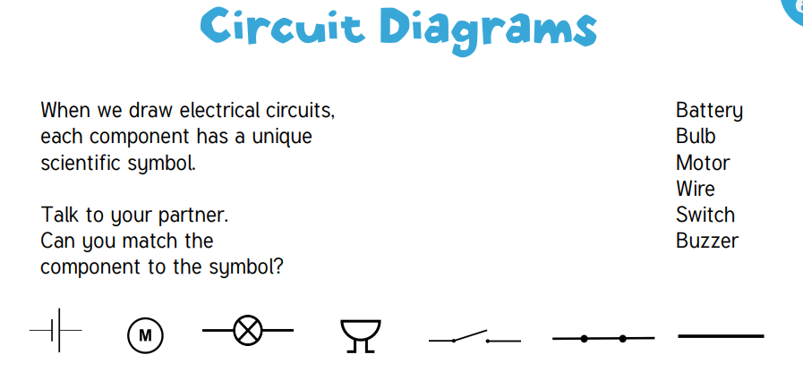  Draw your own circuit using the symbols above. Would it work? Explain why.
Useful links (Click on the word)
- Times Tables Rockstars
- Spelling Shed
- Purple Mash
- Bitesize Home Learning

Home Learning - wb 25/04/22 Week 2
English  Narrative Writing | Monday | Lesson 6
 | Tuesday | Lesson 7
 | Wednesday | Lesson 8
 | Thursday | Lesson 9
 | Friday | Lesson 10
Maths  Place Value | Monday | Lesson 6
 | Tuesday | Lesson 7
 | Wednesday | Lesson 8
 | Thursday | Lesson 9
 | Friday | Lesson 10
Reading  The Blitz Survivor Stories | Monday | Lesson 1
 | Tuesday | Lesson 2
 | Wednesday | Lesson 3
 | Thursday | Lesson 4
 | Friday | Lesson 5
Topic | Mexico – Geography  What are the key physical features of Mexico?  French Lesson 3 and 4  P.E Lesson 2  Computing Lesson 2  PSHE Lesson 2  Art Lesson 2
Science  Electricity | 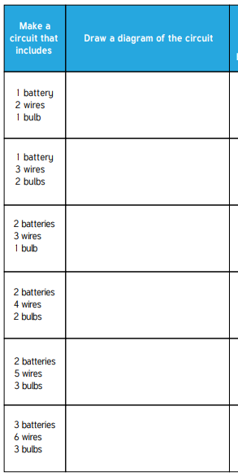  Draw a diagram of the circuit given to you.
Useful links (Click on the word)
- Times Tables Rockstars
- Spelling Shed
- Purple Mash
- Bitesize Home Learning

Home Learning- wb 02/05/22 Week 3
English  Narrative Writing | Monday | Lesson 11
 | Tuesday | Lesson 12
 | Wednesday | Lesson 13
 | Thursday | Lesson 14
 | Friday | Lesson 15
Maths  Calculation Problems | Monday | Lesson 1
 | Tuesday | Lesson 2
 | Wednesday | Lesson 3
 | Thursday | Lesson 4
 | Friday | Lesson 5
Reading  The Greenling by Levi Pinfold | Monday | Lesson 1
 | Tuesday | Lesson 2
 | Wednesday | Lesson 3
 | Thursday | Lesson 4
 | Friday | Lesson 5
Topic | Mexico – Geography  How can Mexico be in North America and Latin America?  Look at a map of Latin America. What do you notice about where the Latin American countries are located?  Use a Venn diagram to show what Mexico has in common with other Latin American countries and North American countries to show that a place can belong to more than one region depending on what defines those regions.  French Lesson 5  P.E Lesson 3  Computing Lesson 3  PSHE Lesson 3  Art Lesson 3
Science  Electricity | 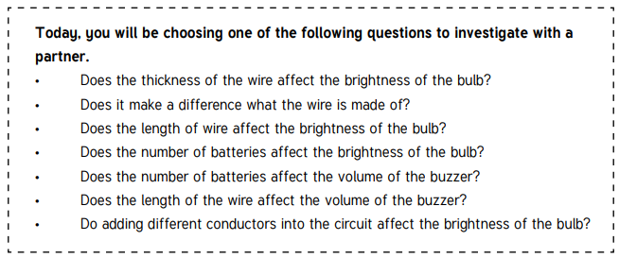
Useful links (Click on the word)
- Times Tables Rockstars
- Spelling Shed
- Purple Mash
- Bitesize Home Learning

Home Learning- wb 09/05/22 Week 4
English  Narrative Writing | Monday | Lesson 16
 | Tuesday | Lesson 17
 | Wednesday | Lesson 18
 | Thursday | Lesson 19
 | Friday | Lesson 20
Maths  Calculation Problems | Monday | Lesson 6
 | Tuesday | Lesson 7
 | Wednesday | Lesson 8
 | Thursday | Lesson 9
 | Friday | Lesson 10
Reading  Holes by Louis Sachar | Monday | Lesson 1
 | Tuesday | Lesson 2
 | Wednesday | Lesson 3
 | Thursday | Lesson 4
 | Friday | Lesson 5
Topic | Mexico – Geography  Where are all the people?  This lesson should focus on the distribution of human beings in Mexico and provides insights into the different types of settlements across the country. This lesson involves you comparing the demographic characteristics of different states in Mexico.  French Lesson 1 and 2  P.E Lesson 4  Computing Lesson 4  PSHE Lesson 4  Art Lesson 4
Science  Electricity | 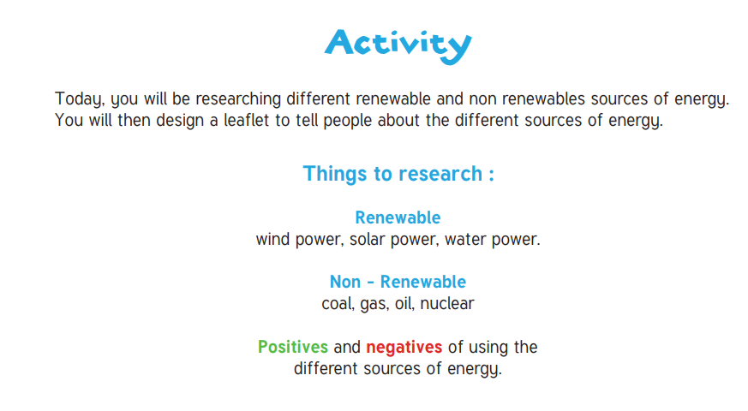
Useful links (Click on the word)
- Times Tables Rockstars
- Spelling Shed
- Purple Mash
- Bitesize Home Learning

Home Learning- wb 16/05/22 Week 5
English  Narrative Writing | Monday | Lesson 21
 | Tuesday | Lesson 22
 | Wednesday | Lesson 23
 | Thursday | Lesson 24
 | Friday | Lesson 25
Maths  Large Numbers | Monday | Lesson 6
 | Tuesday | Lesson 7
 | Wednesday | Lesson 8
 | Thursday | Lesson 9
 | Friday | Lesson 10
Reading  The Giant's Necklace by Michael Morpurgo | Monday | Lesson 1
 | Tuesday | Lesson 2
 | Wednesday | Lesson 3
 | Thursday | Lesson 4
 | Friday | Lesson 5
Topic | Mexico – Geography  What would it be like to live in the Chihuahuan desert?  Use maps, atlases and globes to locate the Chihuahuan Desert.  Learn about the animal and plant species found there, what the climate is like, its location in relation to the equator.  Write a report about what you have learnt.  French Lesson 3 and 4  P.E Lesson 5  Computing Lesson 5  PSHE Lesson 5  Art Lesson 5
Science  Electricity | Explain which energy is the best type of energy and why.
Useful links (Click on the word)
- Times Tables Rockstars
- Spelling Shed
- Purple Mash
- Bitesize Home Learning

Home Learning- wb 23/05/22 Week 6
English  Narrative Writing (Monday and Tuesday) | Monday | Lesson 26
 | Tuesday | Lesson 27
 | Wednesday | Simple and Compound Sentences
 | Thursday | To explore complex sentences
 | Friday | Relative Clauses
Maths  Large Numbers | Monday | Lesson 11
 | Tuesday | Lesson 12
 | Wednesday | Lesson 13
 | Thursday | Lesson 14
 | Friday | Lesson 15
Reading  The Blitz Survivor Stories | Monday | Lesson 1
 | Tuesday | Lesson 2
 | Wednesday | Lesson 3
 | Thursday | Lesson 4
 | Friday | Lesson 5
Topic | Mexico – Geography  What threats to framing are there?  What is the same and different about the threats facing a farming region in Mexico and the UK?  French Lesson 1 and 2  P.E Lesson 6  Computing Lesson 6  PSHE Lesson 6  Art Use the knowledge you have gained about graphic design to draw the heart is 3D form.
Science  Electricity | Create a poster to tell younger children how to save energy.
Useful links (Click on the word)
- Times Tables Rockstars
- Spelling Shed
- Purple Mash
- Bitesize Home Learning

