Principal: Miss K Langley
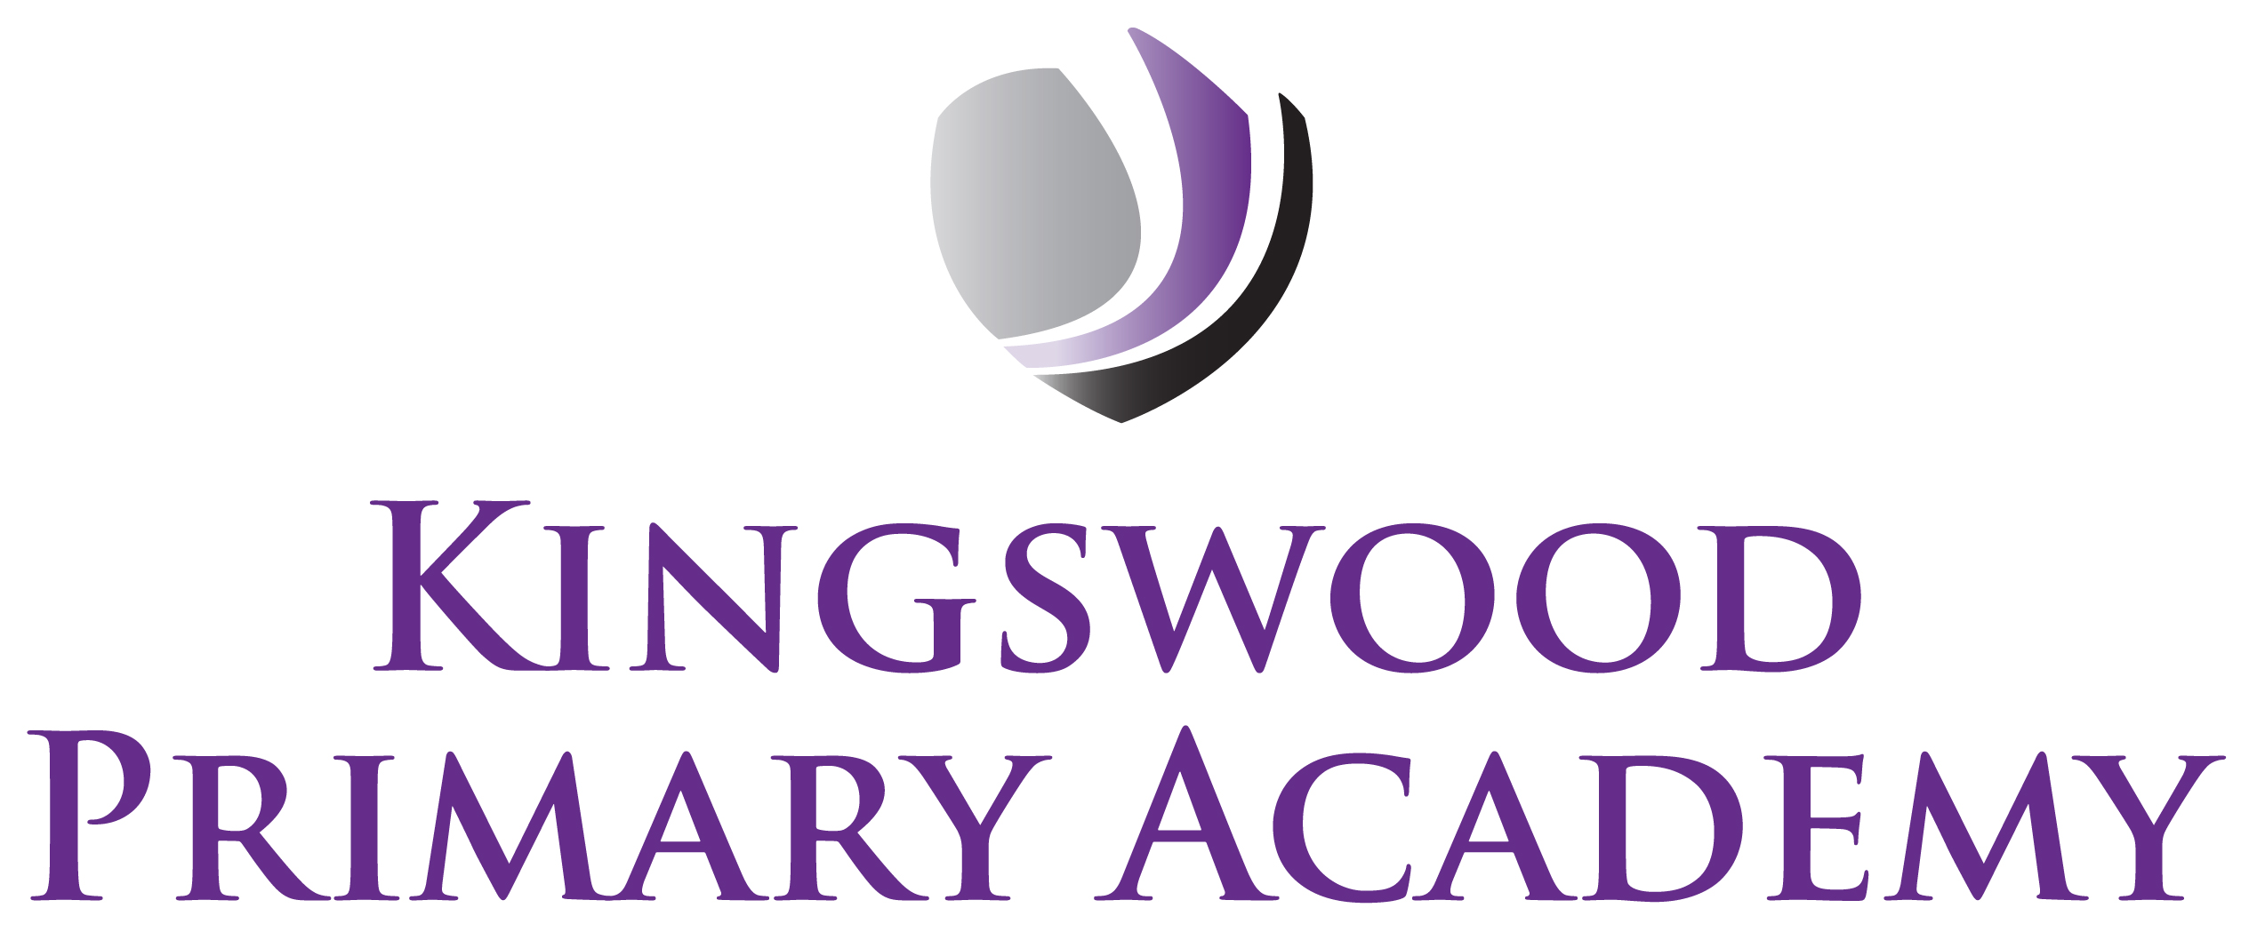

Acting Assistant Principals: Mrs J Smith & Mr J Mathew
SENDco: Mrs K Prior
Southbrook, Corby, Northamptonshire NN18 9BE

Telephone: 01536 742677
Email: admin@kingswoodprimaryacademy.org
Website: www.kingswoodprimaryacademy.org


@kingswoodpri
Kingswood Primary Academy
May 2026

Dear Parent/Guardian

BURGHLEY HOUSE – YEAR 3 – THURSDAY 2ND JULY 2026

As part of our topic this term the children in Year 3 are learning about Tudors. We would like to take the children on a trip to Burghley House in Stamford, where they will be able to go back in time to when the Tudors ruled. This will be a great experience for the children to discover how the Tudors lived. The trip will take place on Thursday 2nd July 2026. Children will need to arrive at School by 8:30am as we leave for Burghley at 9:00am and return to School around 3:15pm.

The total cost of this trip is £630.00. We are asking for a parent/guardian contribution of £12.00 per child. Payments are to be made on Parentpay.com as we are no longer taking cash for trips. If you need any help with this, please call into the office.

Please provide your child with a home-packed lunch (no chocolate, fizzy drinks or sweets please). If your child normally receives a free school meal, a packed lunch will be provided on the day, please book a meal online at www.kingswoodcatering.co.uk also please bring a backpack to keep lunch in.

Children are invited to dress in Tudor costume if they wish, but this is not compulsory, some suggestions are given below:

Boys:
Open necked shirt with scarf tied around neck. Trousers cut off at the knees or tucked into socks. Waistcoat or similar. Boots or shoes and a cap.

Girls:
Long skirt or petticoat. Blouse, apron, shawl, mop cap. Boots or shoes.

If you have any questions, please don’t hesitate to contact us.

Kind regards

Mr J Hall
Year 3 Class Teacher

