Principal: Miss K Langley
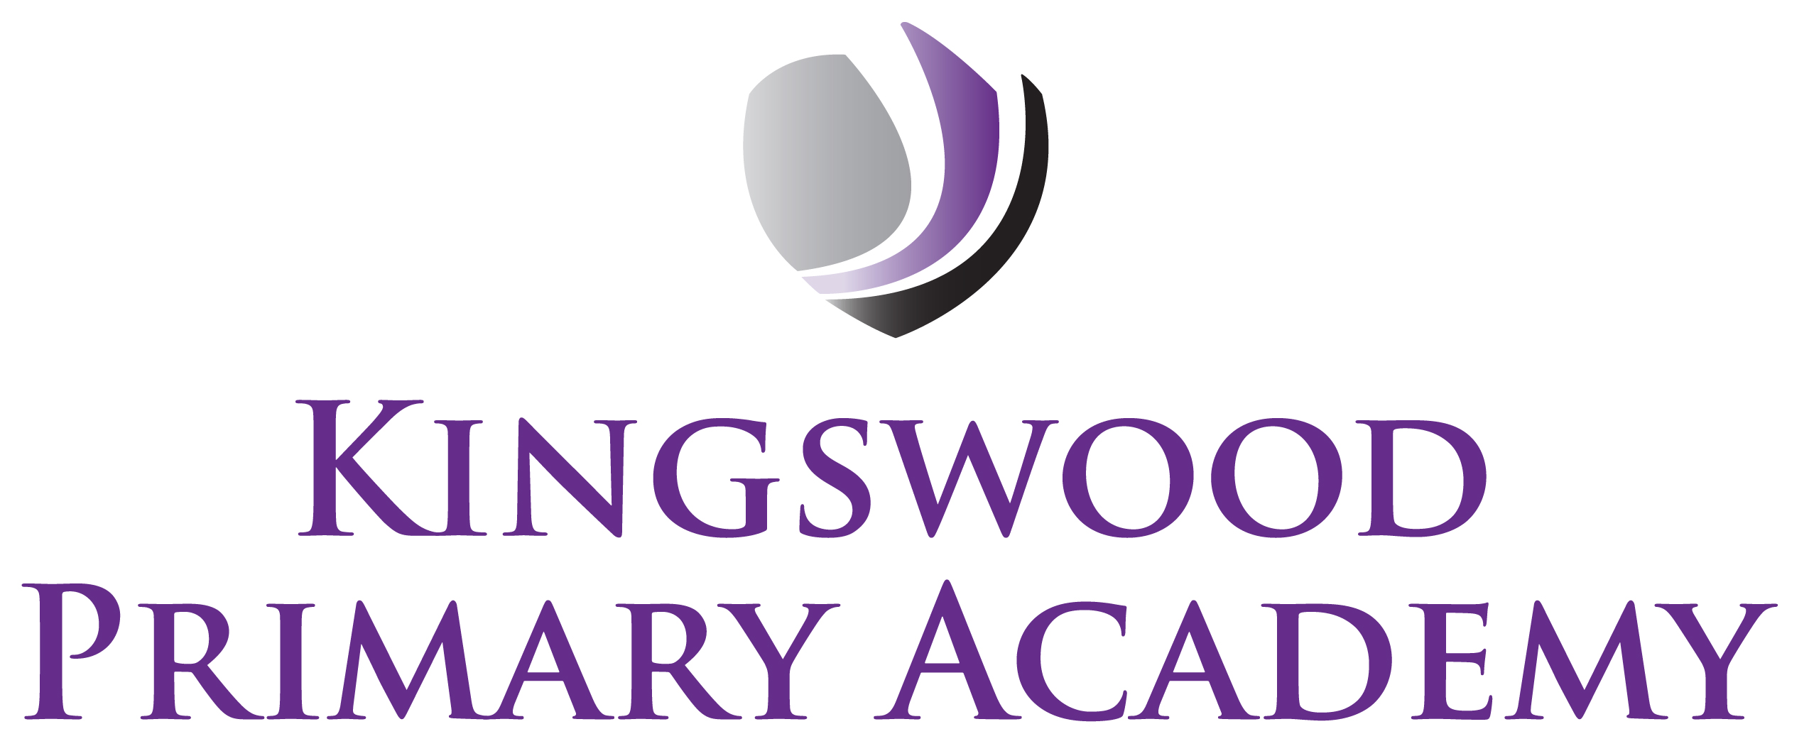

Acting Assistant Principals: Mrs J Smith & Mr J Mathew
SENDco: Mrs K Prior
Southbrook, Corby, Northamptonshire NN18 9BE

Telephone: 01536 742677
Email: admin@kingswoodprimaryacademy.org
Website: www.kingswoodprimaryacademy.org


kingswoodpri
Kingswood Primary Academy
May 2026

Dear Parents/Carers

Holdenby House Year 5 Trip – Thursday 18th June 2026

As part of our history learning, we would like to take the children in Eagles Class on an educational visit to Holdenby House. This trip will take place on Thursday 18th June 2026. Children will need to arrive at School at 8:45am ready for us to leave at 9:00am. We will return to school at approximately 3:00pm, so home time should be unaffected.

The total cost of this trip is £666.80. We are asking for a parental contribution of £11.00. per child. Payments are to be made on Parentpay.com as we are no longer taking cash for trips. If you need any help with this, please call into the office.

Please provide your child with a home-packed lunch (no chocolate, fizzy drinks or sweets please). If your child normally receives a free school meal, a packed lunch will be provided on the day, please book a meal online at www.kingswoodcatering.co.uk also please bring a backpack to keep lunch in.

During the trip, children will spend the day doing a variety of hands-on activities and having an insight into the life and times of a Victorian Servant. It is a fully immersive experience, where the children will meet costumed actors and deepen their Victorian learning. In their role as a Victorian Servant, it would be fantastic if children could dress in appropriate costumes. Some suggestions are given below:

Boys:
Open necked shirt with scarf tied around neck. Trousers cut off at the knees or tucked into socks. Waistcoat or similar. Boots or shoes and a cap.

Girls:
Long skirt or petticoat. Blouse, apron, shawl, mop cap. Boots or shoes.

It is also recommended to bring a coat, as there may be some activities outside.

If you have any questions, please don’t hesitate to contact us.

Kind regards

Miss S Johnson
Year 5 Class Teacher

