Principal: Miss K Langley
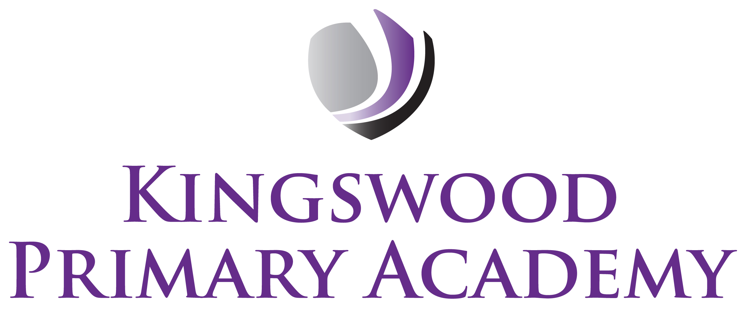

Acting Assistant Principals: Mrs J Smith & Mr J Mathew
SENDco: Mrs K Prior
Southbrook, Corby, Northamptonshire NN18 9BE

Telephone: 01536 742677
Email: admin@kingswoodprimaryacademy.org
Website: www.kingswoodprimaryacademy.org


@kingswoodpri
Kingswood Primary Academy

May 2026

Dear Parent/Guardians

Flag Fen – Tuesday 2nd June 2026

Pupils in Year 3 are studying Anglo Saxons and as part of this project we have arranged a trip to Flag Fen in Peterborough. It will be a fantastic opportunity as the children will be archaeologists for the day, discovering how we find out about the past. Children will need to wear waterproof clothing and have boots or wellingtons, along with a change of shoes and socks in a carrier bag as at times it may be muddy. If they could also bring a hat and some suncream just in case. They will not need any money to spend there.

The trip will take place on Tuesday 2nd June 2026. We will leave the school at 9:00am and plan to leave Flag Fen at 2:00pm so that the children are back at school for the end of the day.

Please provide your child with a home packed lunch (no chocolate, fizzy drinks or sweets please). If your child normally receives a free school meal, a packed lunch will be provided on the day, please book this online at www.kingswoodcatering.co.uk also please bring a backpack to keep lunch in.

The total cost of this trip is £724.45, we are asking for a parent/guardian contribution of £17.00 per child. Payments are to be made on Parentpay.com. If you need any help with this please call into the office. Please can this trip be paid for by Thursday 21st May 2026.

Please do not hesitate to contact us with any questions that you may have.

Kind regards

Mr J Hall
Year 3 Class Teacher

