Principal: Miss K Langley
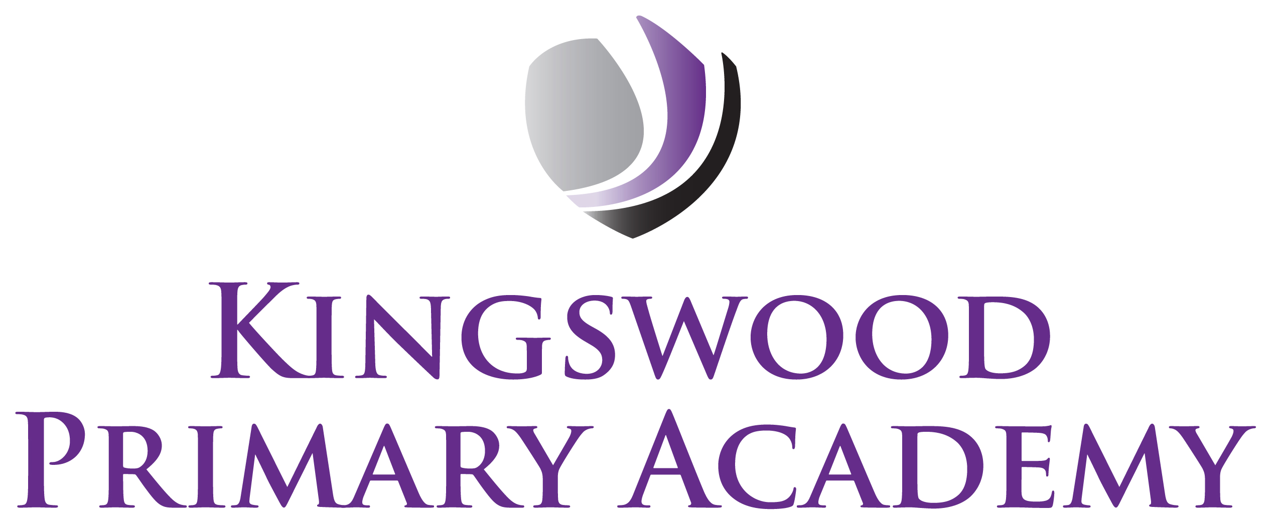

Acting Assistant Principals: Mrs J Smith & Mr J Mathew
SENDco: Mrs K Prior
Southbrook, Corby, Northamptonshire NN18 9BE

Telephone: 01536 742677
Email: admin@kingswoodprimaryacademy.org
Website: www.kingswoodprimaryacademy.org

@kingswoodpri

Kingswood Primary Academy

April 2026

Mablethorpe Camping Trip – Monday 6th July/Tuesday 7th July

Dear Parent/Guardians,

In July pupils in Year 4 have a fantastic opportunity to go on a camping trip to another GAT school in Mablethorpe. This trip will take place on Monday 6th July & Tuesday 7th July.

While in Mablethorpe the children will take part in team building activities, play games and sit around a campfire. In the evening they will have fish/sausage/chicken nuggets & chips supper and then camp in tents provided by Greenwood Academies Trust. They will explore the beach through various activities and have the chance to go paddling in the near-by paddle park. They will be returning to school around 5pm. The tents will be in a secure school site where the gates will be locked and there will be 4 members of staff with the children.

Children will need to come to school in older clothes and bring items on the attached list. Greenwood Academies can provide sleeping bags if you do not have one. (Please let us know if you need a sleeping bag).

Please make sure that your child arrives at school by 8.30am as the coach will leat at 9.00am prompt. If your child is entitled to a free school meal, and you would like to book one for this trip, please go online to www.kingswoodcatering.co.uk. If not, then your child is required to bring a packed lunch with them. Please can lunches be in a named carrier bag so that it can be thrown away, only send disposable water bottles. Lunch on the second day will be provided. The PTA will be buying the children ice-creams.

The cost of this trip is £1465.00 and we are asking Parents/Guardians to make a contribution of £20.00 per child. Payment is to be made on Parentpay.com. If you need any assistance with parentpay then please call the school office. Please return the attached slip. Please can payment be made by Tuesday 30th June.

Yours sincerely

Mrs Wagg
Class Teacher

Mablethorpe 2026

Child……………………………………………………………………………………………………………………………………………………….

( ) needs a sleeping bag to be provided

( ) can have an icecream

Meal choice
( ) fish & chips
( ) sausage & chips
( ) chicken nuggets & chips
( ) fishcake & chips

Signed…………………………………………………………………………………………………………………………. Parent/Guardian

