Principal: Miss K Langley
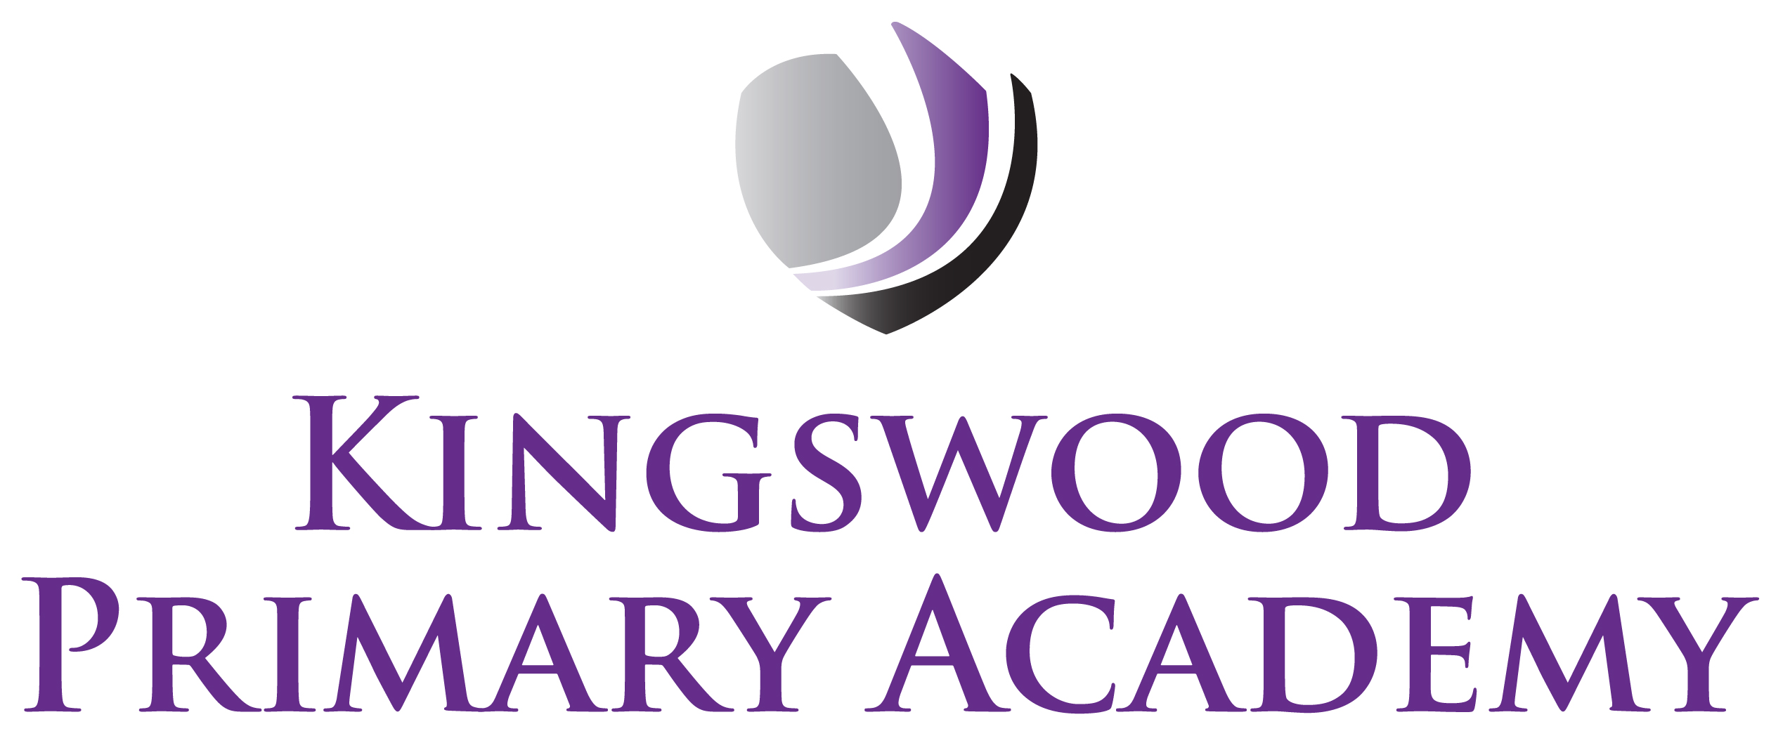

Acting Assistant Principals: Mrs J Smith & Mr J Mathew
SENDco: Mrs K Prior
Southbrook, Corby, Northamptonshire NN18 9BE

Telephone: 01536 742677
Email: admin@kingswoodprimaryacademy.org
Website: www.kingswoodprimaryacademy.org


@kingswoodpri
Kingswood Primary Academy

May 2026

Dear Parents/Guardians

Hunstanton – Tuesday 14th July 2026

Linking to our writing topics this term, we would like to take the children in Squirrels Class on a day trip to Hunstanton. This trip will take place on Tuesday 14th July. Children need to arrive at school by 7:45am as we leave for Hunstanton at 8am prompt. We will return to school at approximately 5:15pm. The cost of this trip is £730.00 and we are asking for a parental contribution of £18.00. Payments are to be made on Parentpay.com. If you need any help with this please call into the office. The PTA are kindly funding an ice-cream for all of the children, if you do not wish your child to have an ice-cream you can tick the box on Parentpay. Please can this trip be paid for by 8th July 2026.

Please provide your child with a home packed lunch (no chocolate, fizzy drinks or sweets please). If your child normally receives a free school meal, a packed lunch will be provided on the day, please book a meal online at www.kingswoodcatering.co.uk also please bring a backpack to keep lunch in.

The children will be going on the beach. If the weather is hot, could you please put suncream on your child in the morning and send a hat. Children do not have to wear school uniform, but sensible, practical clothing is to be worn, including a jacket. Children need to bring a named bag with a change of clothes and a towel, as they may be paddling in the sea! If children desire, they can bring a named bucket and spade, which will be their responsibility once on the beach. They will not need any money.

Kind regards

Miss Grkinic
Year 1 Teacher

