Principal: Miss K Langley
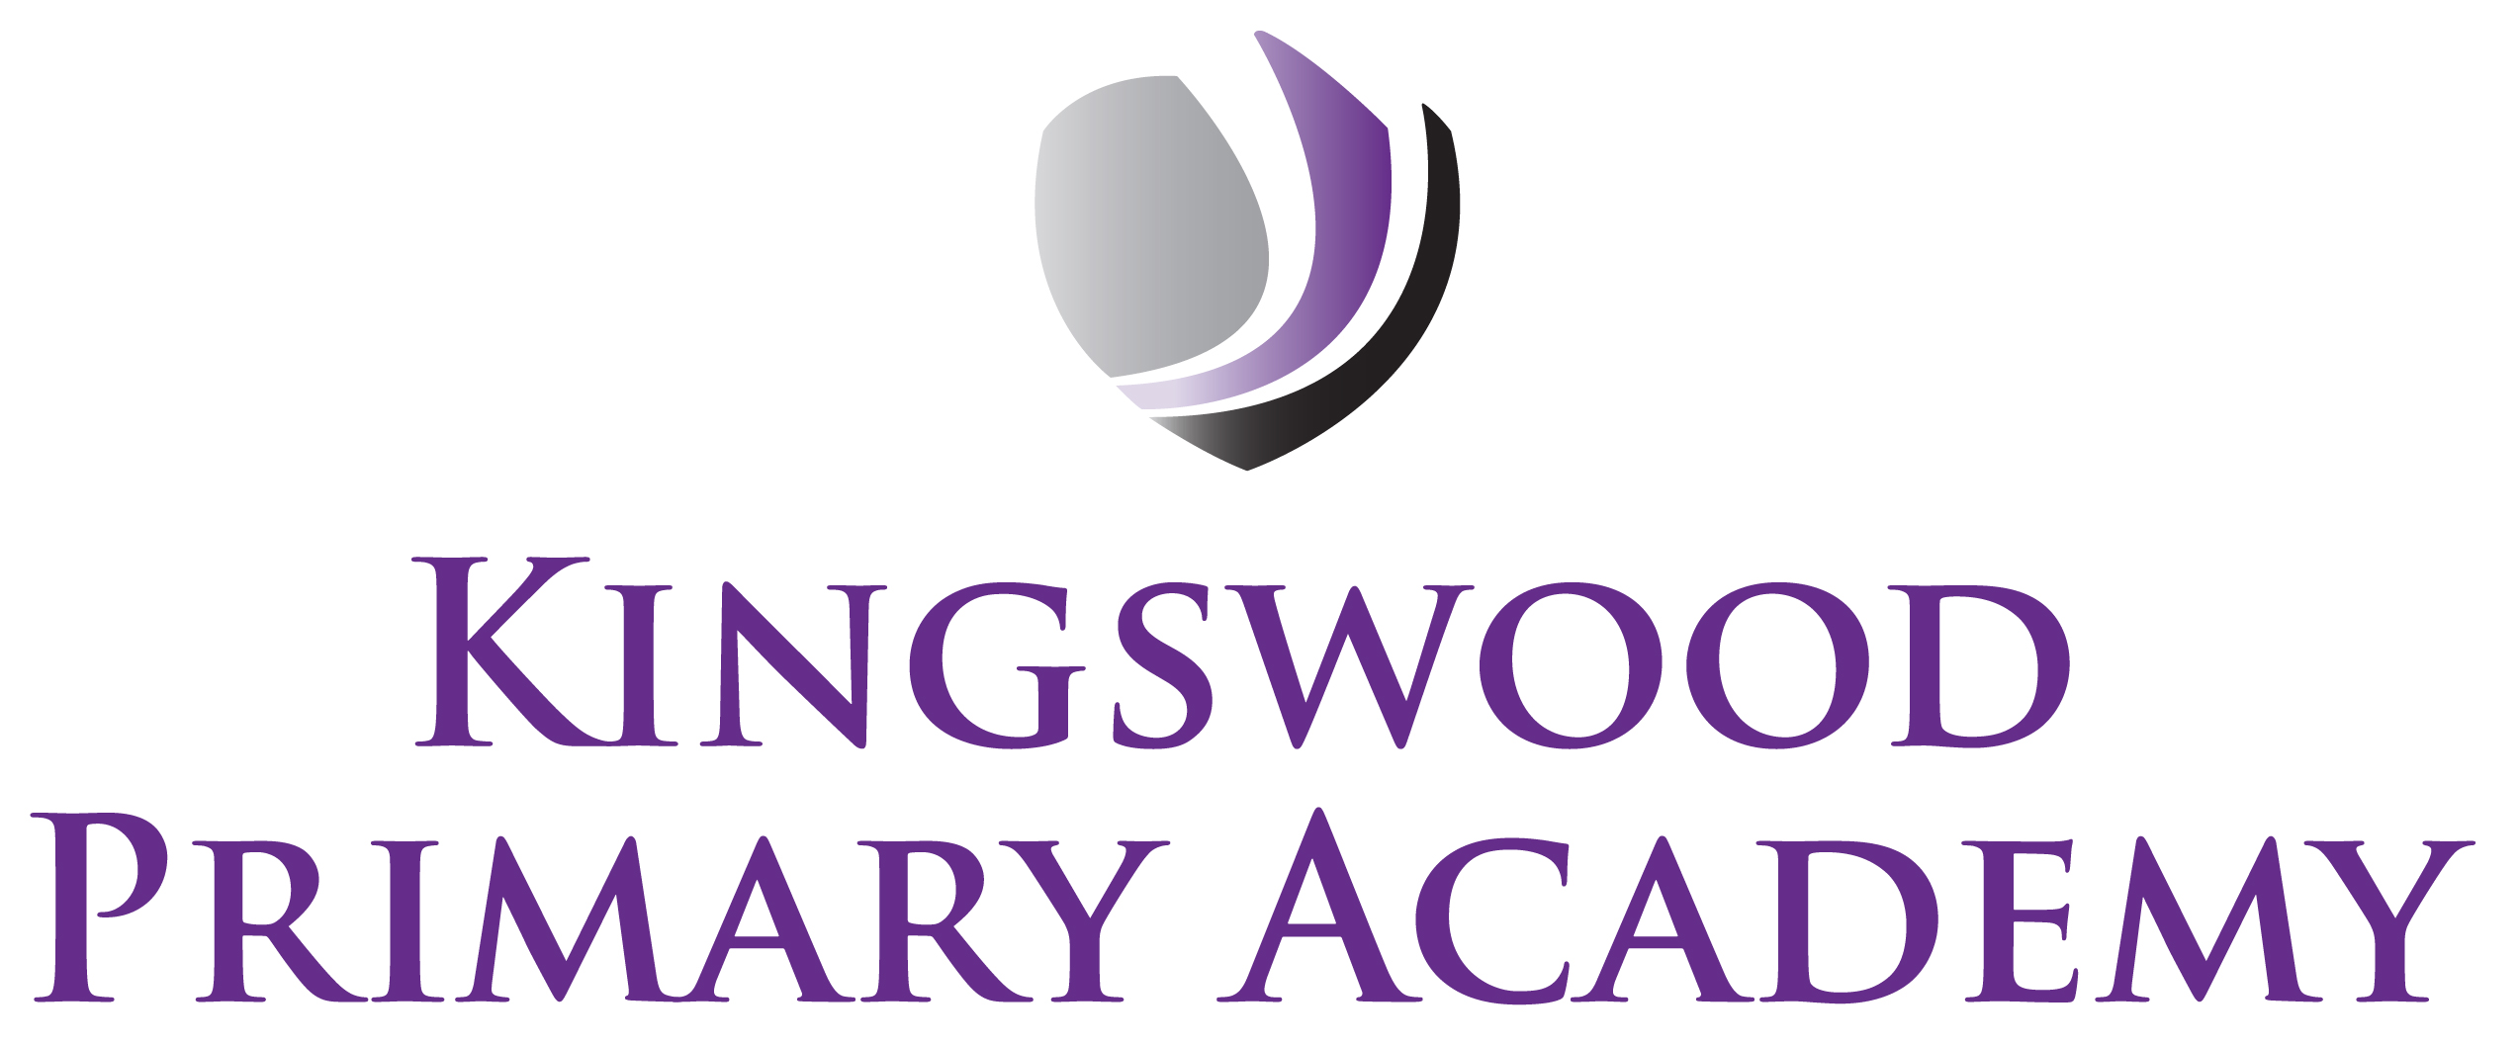

Acting Assistant Principals: Mrs J Smith & Mr J Mathew
SENDco: Mrs K Prior
Southbrook, Corby, Northamptonshire NN18 9BE

Telephone: 01536 742677
Email: admin@kingswoodprimaryacademy.org
Website: www.kingswoodprimaryacademy.org


@kingswoodpri
Kingswood Primary Academy

April 2026

Dear Parents/Guardians

Leicester Space Centre Trip – Wednesday 20th May 2026

This term, Pupils in Year 5 will be studying “Astronomy” and as part of this project we have arranged a visit to the National Space Centre in Leicester on Wednesday 20th May. The children will have a fantastic day and will get to explore the various topics they are learning about. Please make sure your child arrives at school by 8:30am as the coach leaves at 9:00am promptly. We will return to school by 4:00pm. We do ask that the children wear school uniform as it makes it easier to identify them, and also comfortable shoes.

Please provide your child with a home packed lunch (no chocolate, fizzy drinks or sweets please). If your child normally receives a free school meal, a packed lunch will be provided on the day, please book a meal online at www.kingswoodcatering.co.uk also please bring a backpack to keep lunch in.

We have arranged for the children to all have a stationery gift pack costing £3.00 instead of going to the gift shop, the cost is included in the price below.

The total cost of this trip is £857.25 and we are asking for a contribution of £18.00 per child. Payments can be made on Parentpay.com by the 14th May.

Yours faithfully

Miss S Johnson
Year 5 Class Teacher

