Principal: Miss K Langley
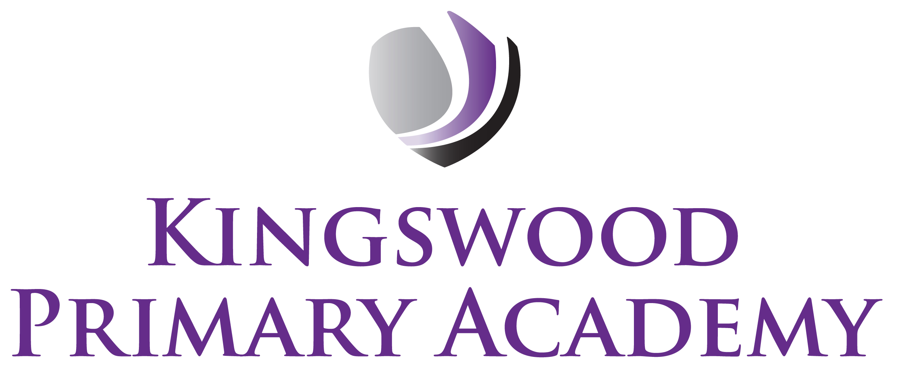

Acting Assistant Principals: Mrs J Smith & Mr J Mathew
SENDco: Mrs K Prior
Southbrook, Corby, Northamptonshire NN18 9BE

Telephone: 01536 742677
Email: admin@kingswoodprimaryacademy.org
Website: www.kingswoodprimaryacademy.org


@kingswoodpri
Kingswood Primary Academy
April 2026

Dear Parents and Carers
Alton Towers – Year 6 – 25th June 2026

I am pleased to inform you that, as a reward for the children’s excellent behaviour, effort and commitment to our school values throughout the year, we are planning a special end-of-term trip to Alton Towers Theme Park.

The visit will take place on Thursday 25th June. It will be a wonderful opportunity for pupils to relax, celebrate their achievements and enjoy time with their peers in a safe and supervised environment.

The cost of the trip will be £24 per child, which includes entrance to the park and coach travel. We appreciate that costs can be challenging for some families, so please note that payment can be made in two instalments of £12 with payments being made via Parentpay.

We are also very grateful to the PTA who have kindly agreed to contribute funds so that each child will be provided with an ice cream on the day as an additional treat.

Please note that as refreshments are being provided, children do not need to bring any spending money with them on the day of the trip. Please can children wear PE Kit and leavers hoodies (due in school shortly).

Please provide your child with a home-packed lunch (no chocolate, fizzy drinks or sweets please). If your child normally receives a free school meal, a packed lunch will be provided on the day, please book this online at www.kingswoodcatering.co.uk please can lunches be in a carrier bag so that it can all be thrown away, only send disposable water bottles.

Please make sure your child arrives at School at 7:45am as the coach will leave at 8:00am prompt. We will leave Alton Towers at 4:30pm arriving back in School around 6:30pm. ALL children must be collected on return.

Thank you for your continued support. We look forward to giving the children a memorable and well-deserved experience.

Kind regards

Mr J Mathew
Year 6 Class Teacher

