Principal: Miss K Langley
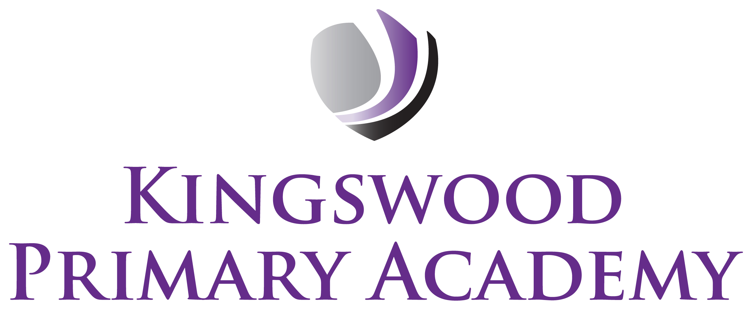

Acting Assistant Principals: Mrs J Smith & Mr J Mathew
SENDco: Mrs K Prior
Southbrook, Corby, Northamptonshire NN18 9BE

Telephone: 01536 742677
Email: admin@kingswoodprimaryacademy.org
Website: www.kingswoodprimaryacademy.org


@kingswoodpri
Kingswood Primary Academy

March 2026

Dear Parents/Carers

Years 1, 2 & 3

The children have an exciting opportunity coming up: we will be visiting Corby Cube Library on Thursday 16th April. During the visit, each child will be assigned their very own library card which will allow them to borrow and exchange books throughout the year.

As part of the trip, the children will also enjoy a tour of The Core Theatre along with a fun activity led by the theatre team.

The children will be walking to the Library accompanied by their Teacher and Teaching Assistants.

Please ensure you complete and return the attached form by next Wednesday (25th March) so that your child is able to receive their library card during the visit.

Thank you for your support.

Miss G
Reading Leader

