Principal: Miss K Langley
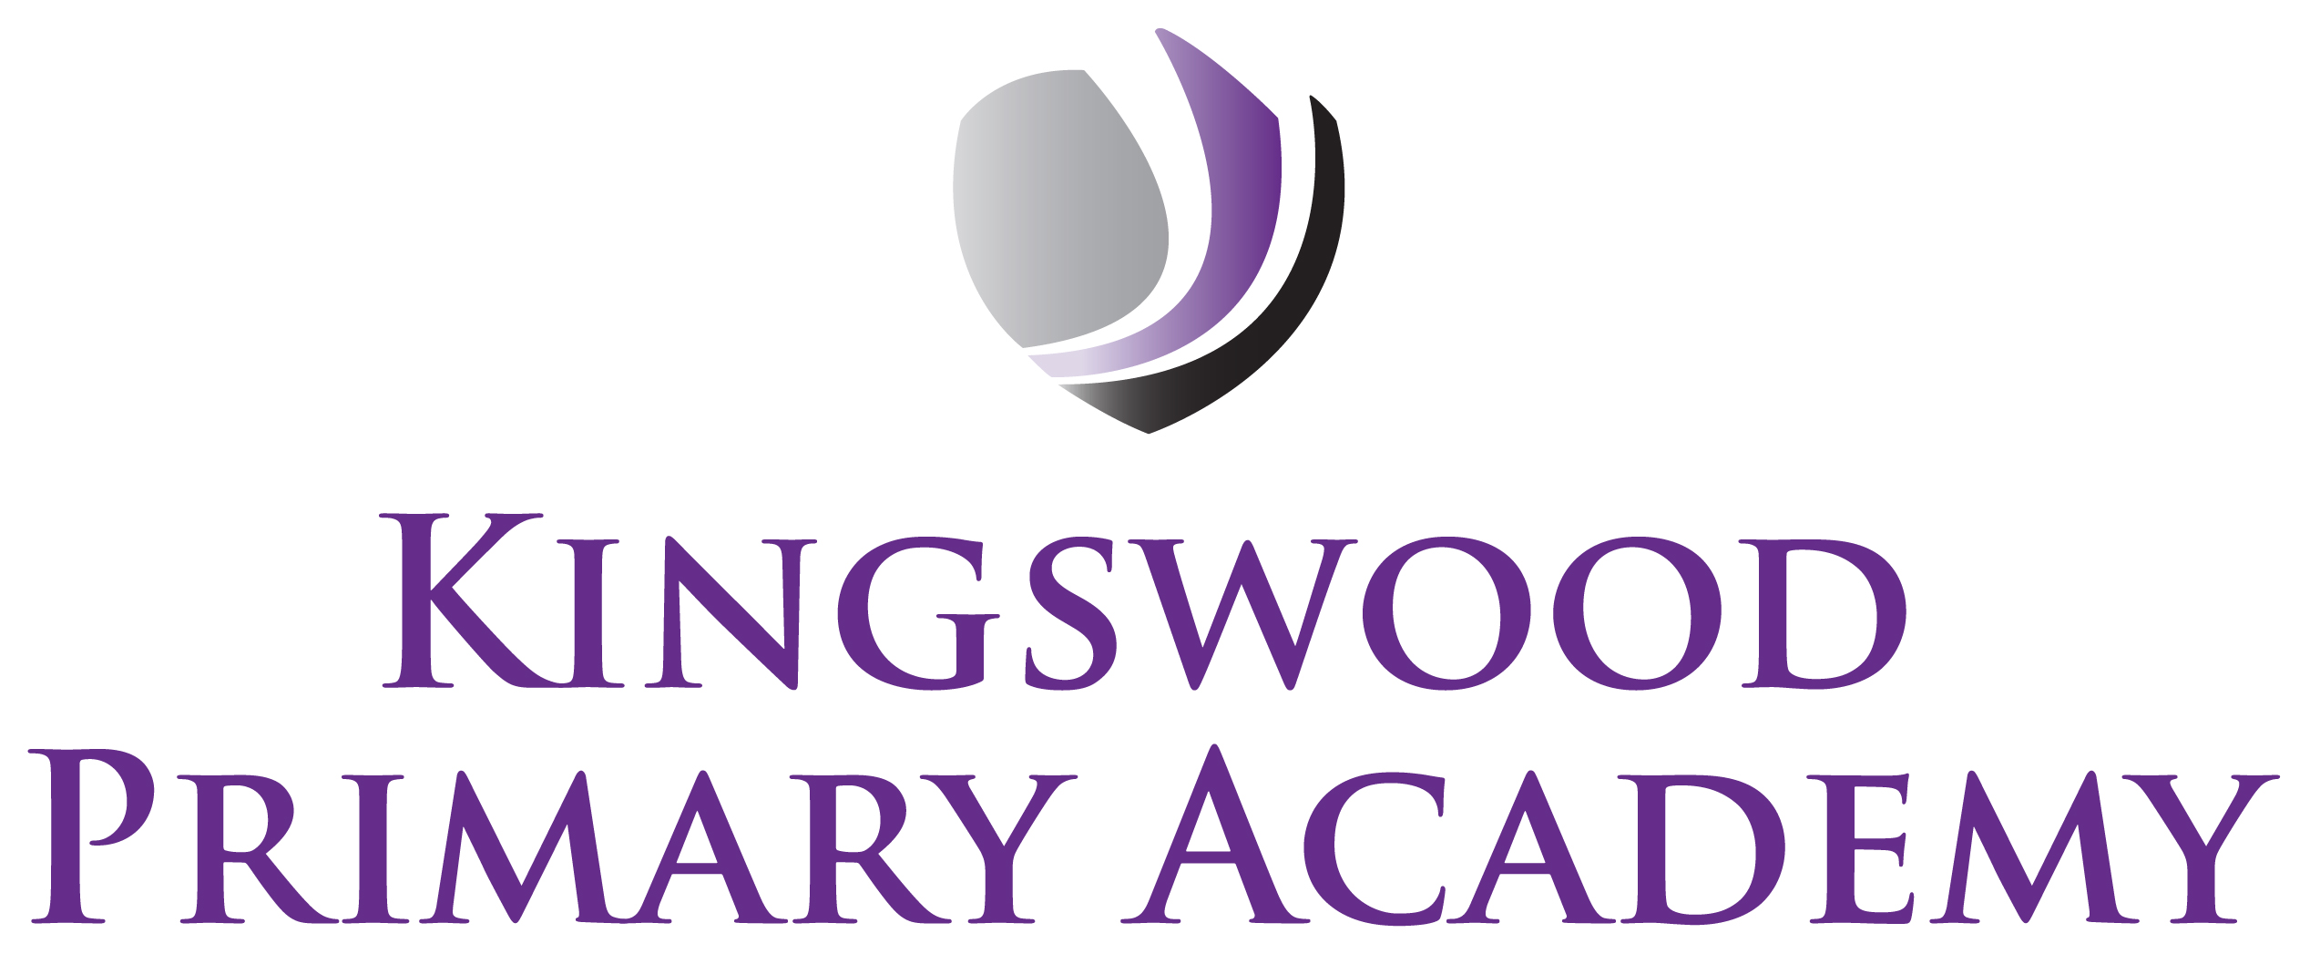

Acting Assistant Principals: Mrs J Smith & Mr J Mathew
SENDco: Mrs K Prior
Southbrook, Corby, Northamptonshire NN18 9BE

Telephone: 01536 742677
Email: admin@kingswoodprimaryacademy.org
Website: www.kingswoodprimaryacademy.org


@kingswoodpri
Kingswood Primary Academy
March 2026
ROCKINGHAM CASTLE - TUESDAY 14TH APRIL 2026
Dear Parents/Carers

This term the children in Year 1 have been learning about Kings and Queens, Castles, and what life was like long ago. We are going to be visiting Rockingham Castle to bring our history learning to life. Rockingham Castle is nearly 1,000 years old and is one of the best examples of a real Norman Castle in our local area. Visiting it helps children understand that the past is real, not just something in books.

The trip will take place on Tuesday 14th April 2026. We will leave the school at 9:15am and plan to leave Rockingham Castle at 2:30pm so that the children are back at school for the end of the day.

If you would like, the children may wear Prince/Princess or Knight costumes. If not, then school uniform is to be worn as normal. Please ensure that they also have a warm coat just in case the weather is bad.

Please provide your child with a home packed lunch (no chocolate, fizzy drinks or sweets please). If your child normally receives a free school meal, a packed lunch will be provided on the day, please book this online at www.kingswoodcatering.co.uk also please bring a backpack to keep lunch in.

The total cost of this trip is £236. We are asking for a parent/guardian contribution of £8.00 per child. Payments are to be made on Parentpay.com. If you need any help with this please call into the office. Please can this trip be paid for by Friday 27th March.

We hope the children have a lovely day with a guided tour of the Castle, exploring the grounds, key historical features and some hands on learning to find out what life was like for people in the past.

Kind regards

Miss M Grkinic
Year 1 Class Teacher

