Executive Principal: Mrs C Barrington
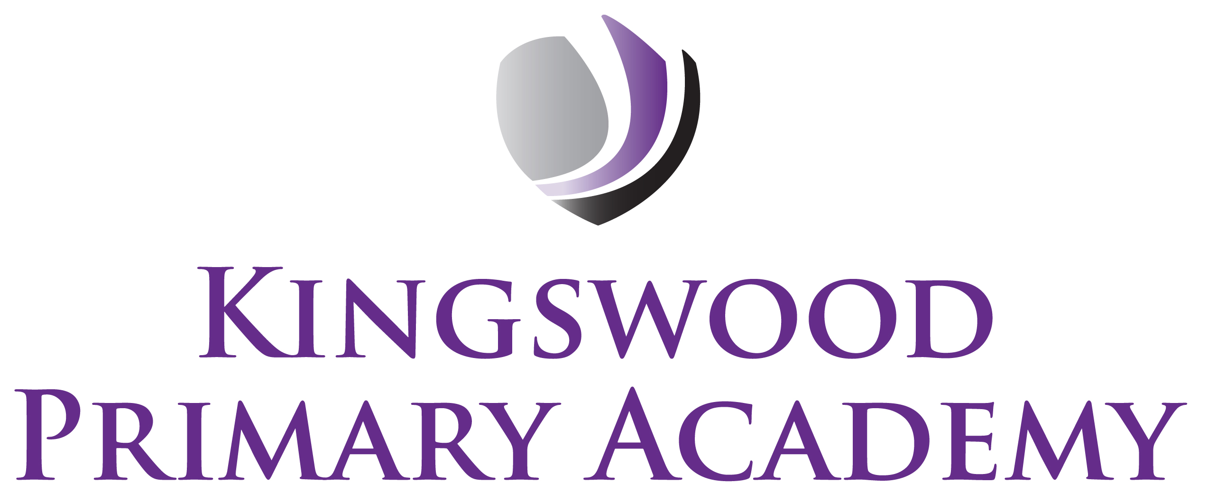

Head of Academy: Miss K Langley

Southbrook, Corby, Northamptonshire NN18 9BE

Telephone: 01536 742677
Email: admin@kingswoodprimaryacademy.org
Website: www.kingswoodprimaryacademy.org


@kingswoodpri
Kingswood Primary Academy

January 2024

Visit to Warwick Castle – Tuesday 19th March 2024

Dear Parent/Guardians,

As part of our topic in Spring term 1, the children in Squirrels Class are learning about Castles. We would like to take the children on a visit to Warwick Castle, where they will be able to explore the castle, learn about what life was like during the medieval period and also see inside the grounds. This will be a great opportunity for the children, allowing them to experience first-hand learning. The visit will take place on Tuesday 19th March. We will leave the school at 9.00am prompt and plan to leave Warwick Castle at 3.00pm. We should arrive back at school around 4.30pm. The total cost of this trip is £970.00 and we are asking for a contribution of £20.00 to be paid per child to towards the cost of this visit. This needs to be paid on Parentpay.com. If you need any assistance with using Parentpay then please call the school office.
We will not be visiting the shop so the children do not need to bring any money.

We would like the children to wear Princess or Knight costumes if they wish, however please ensure they will be warm enough as they will be outdoors. If not, school uniform is to be worn as normal. If you normally book a meal for your child this will be automatically changed to a picnic lunch by the caterers.

Please can the trip cost of £20.00 be made to Parentpay by Monday 11th March.

Yours sincerely

Miss Harris
Class Teacher

